Donor Commitment Form
DEADLINE TO APPEAR IN EVENT PROGRAM 8/1/21

Name: ___________________________________________________________
Please print name exactly as you would like it to appear in the program.

Contact: __________________________________________________________
Title: _____________________________________________________________

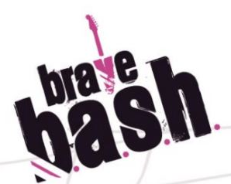
Address: _________________________________________________________

City, State, Zip: ____________________________________________________

Phone: _______________ Email: _____________________________________

Donor Levels & Support Opportunities (Please select all that apply.)

 | Mental Health Champion  $50,000 |  | Ray of Hope  $25,000 |  | Community of Courage  $15,000 |  | Post Traumatic Growth  $10,000 |  | Helping Hands  $5,000 |  | Patron Ticket  $1,500 |  | Ticket  $750

Payment Options
Check

Credit Card Visa MasterCard AMEX

Name on Credit Card: ___________________________________________________________________
Credit Card Number: ____________________________________________________________________
CVV Code: _______________ Exp. Date: __________________Contribute CC Fee (2.6%): Yes No
Billing Address: ________________________________________________________________________
City, State, Zip _________________________________________________________________________
Cardholder Signature: ___________________________________________________________________

Kelly Bustin
Executive Director
kbreeding@artherapyintl.org
813.435.1374

Ava Forney
Event Chair
aforney@artherapyintl.org
813-321.7781
For more information or additional opportunities please contact:
Please email this completed form to info@artherapyintl.com or mail to:
ART International Training & Research - 1511 N. Westshore Blvd., Suite 750 - Tampa, FL 33607
ART International is a 501(c)(3) tax-exempt nonprofit organization. A copy of the official registration (CH49871) and financial information may be obtained from the Florida Department of Agriculture and Consumer Services by calling toll-free within the state 1-800-435-7352.

